Airports Authority of India Achieves Data Consistency & Cuts Project Scheduling time Significantly
“We have been able to standardize processes, which has helped improve productivity of our Project Planners and Project Managers with assured transparency in all project related activities.”
Dr. Kakkan Ramalingam
Executive Director – Information Technology
Airports Authority of India

Airports Authority of India (AAI) manages diverse projects at any given time. To improve conventional method of project management, it was time for the organization to move from manual to electronic solution. This solution had to connect all the Project planners and Project monitors at corporate and regional offices and Project Managers at different airport sites into a cohesive team that would enable collation of information on projects status, and costs at any given point in time.
AAI decided to implement an Online Project Monitoring System (OPMS) using Microsoft Project Server 2003 because it offered the best mix of functionality and flexibility. This would help the organization to continue to grow and manage its portfolio of projects. AAI implemented the solution with the help of Microsoft Consulting Services (MCS) which delivered the end-to-end solution in just two months.


AAI has accrued several benefits. OPMS provides an up-to-date view of enterprise wide projects with the current status and cost. Its collaboration tools have improved intra and inter division coordination. Built on a secure and scalable foundation, the solution integrates with its existing infrastructure as well as business processes.
Customer Profile | Business situation | Solution | benefits
The Airports Authority of India (AAI) created on 1st April 1995 manages 11 international airports, 86 domestic airports and 28 civil enclaves. Its objective is to control and manage the entire Indian airspace. AAI manages various areas related to airports such as airport development and construction services, air traffic management services etc. | AAI used conventional methods to manage its projects. These had some inherent deficiencies such as incomplete or inaccurate data, miscommunication which led to delay in executing projects. Also, at the HQ level, information was not available online, therefore, it caused delays in collating statistics on portfolio and project management. | AAI decided to implement an enterprise wide solution for Online Project Monitoring that would provide a foundation for its project management requirements. It appointed MCS for its core skills to roll out the Project Server 2003 based solution from joint application requirement to deployment. | - Standardization of Project Management Tools and Practices  - Consistent Portfolio Reporting and Analysis  - Deliver Projects Efficiently  - Collaborate Effectively  - Scalable, Secure Foundation  - Integrates with Infrastructure and Business Processes  - Knowledge Bank


“We believed that we could use state-of-the-art IT solution to improve the functioning of AAI and bring further transparency to the organization.
I am happy to note that various divisions of AAI are using OPMS as an effective and strategic tool. I am sure this will improve overall project management capability at AAI and the organization will be able to handle more projects in a timely manner.”
K. Ramalingam
Chairman ,
Airports Authority of India
Chairman
Airports Authority of India

The Airports Authority of India (AAI) formed by the merger of International Airports Authority of India (IAAI) and National Airports Authority (NAA). It manages 11 international airports, 86 domestic airports and 28 civil enclaves. AAI focuses on five key functions which include Airport Development and Construction Services; Air Traffic Management Services; Communication, Navigation and Surveillance (CNS) Services; and Ground Support and Safety Services.
EPM Project Commissioned With
No. of Users | 50
No. of Project Managers | 25
Project Web Access | 25
No. of Locations | 15
No of Projects in database | 10
Average No. of Tasks in database | 200

AAI undertakes assignments like airport feasibility studies, airport design project implementation and project supervision, manpower training, airport management and operation on turnkey basis.
The airport projects are usually of a very large size with sub projects being implemented simultaneously. For example, in the construction of an airport terminal the following key players are involved: airport planner, architects and designers, construction engineers, communication engineers, ground support service engineers and different contractors for equipment supply and installation. The process of coordination among the various departments coupled with the involvement of various government departments for approvals do cause delays. Furthermore, communication delays may be caused because all decision makers do not sit in the same office or location.
There are several projects underway at AAI. Those could be strategic projects related to design, construction, or maintenance of airports. Multiple projects are undertaken simultaneously that add to the workload.
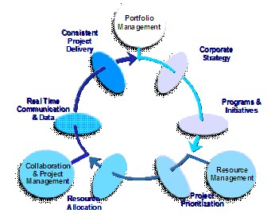
Overview: Online Project Management System

Manual project management was turning out to be a time consuming process which resulted in inaccurate information, incomplete data and misinterpretation of information.
Also, the process for budgeting and tracking the projects on an ongoing basis was time consuming.
These deficiencies in the conventional process led AAI to evaluate various IT driven, enterprise-wide project management solutions available.
The increase in complexity to manage the sheer number of projects, as well as, the quality being delivered by vendors and contractors and providing transparency are important. With these objectives in mind, the organization decided to implement Online Project Management System.


Airports Authority of India evaluated the option available in the market and decided to go with Microsoft Project Server 2003 based solution.
“We wanted this to be a complete success as it is for the first time that a government organization was implementing e-solution for management of projects of high complexity. Microsoft is a software leader, and we felt that they are ideally suited to help us with the OPMS project,” adds Dr. K. Ramalingam,Executive Director.
“The well organized project management and timely coordination between MCS and AAI team, along with MCS commitment to this project has enabled us to complete the implementation in just over two months. The very success of implementing the online Project Monitoring System a day ahead of the scheduled completion was well recognized by not less than the Hon’ble Minister of Civil Aviation. The secret of this success story was entirely due to the top down management support from the Chairman and Members, and a systematic project management plan by the IT team in AAI”
Dr. Kakkan Ramalingam
Executive Director – Information Technology
Airports Authority of India

AAI partnered with Microsoft Consulting Services for this project, as it believed that the organization had core strengths in project management and would add value while delivering an Online Project Monitoring System.
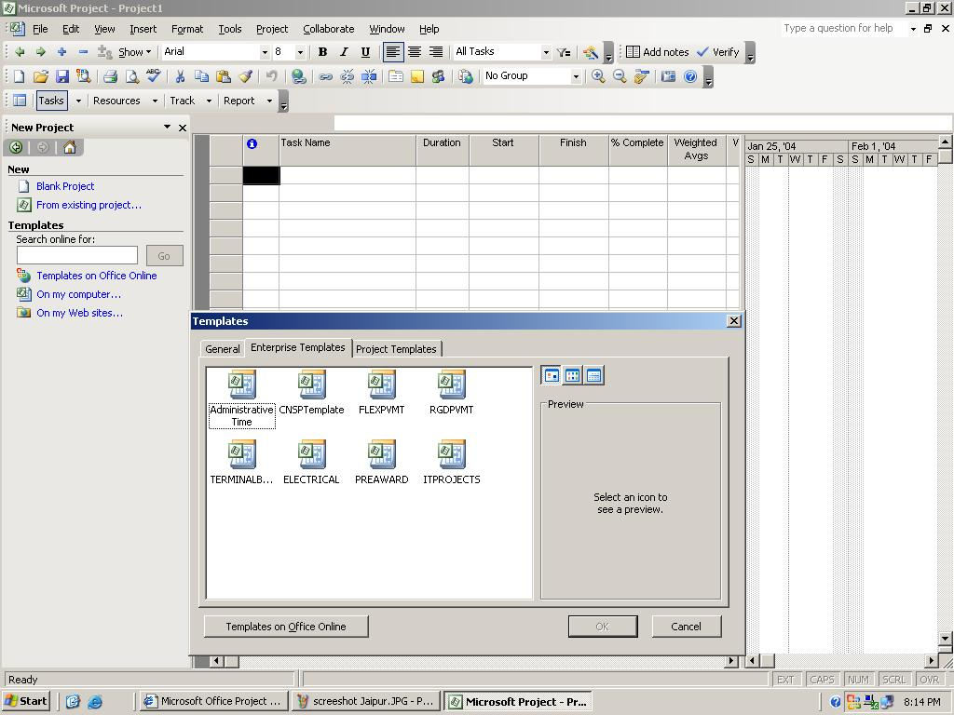
Customizable Templates:
Improving Efficiency, Transparency & Quality of Project management

MCS delivered an end-to-end solution from writing the joint application requirement, design, implementation and skills transfer through hands on training and courseware. The support from the Information Technology team at AAI was crucial in deploying the solution in time.
The project planner details all the sub activities involved in the project as professionally designed structured templates. This helps the Field Project Manager to handle the tasks even if the person is a first time executor of the project.
The standard templates can be customized for projects related to airport terminals, Ground Support & Safety Services, runway works etc. Since project schedules are detailed in the templates, it ensures transparency in all activities. Additionally, various departments can make simultaneous contributions to the project.

The project was successfully completed in just over 2 months. This was possible because of the commitment of the top management, as well as the participation of senior users in defining the functionality for the solution. 37 Project Managers of AAI have been trained on the solution as a part of the project delivery. AAI has been successfully using enterprise project management since February 2004.


Microsoft Office System
- Project Server 2003
- Project Professional
- Project Web Access
- SharePoint Portal Server 2003

Microsoft Windows Server System™
- Windows Server™ 2000
- SQL Server™ 2000

Hardware
- Project Server runs on HP ML 370, Pentium III, Dual processor, 797 MHz, 1GB RAM
- The Database Server runs on HP ML 370, Xeon Dual Processor, 3 GHz, 2 GB RAM

Partner
Microsoft Consulting Services

Another unique feature which enables greater transparency is the method of weighted averages. This methodology gives a weighted average for each task completed. Therefore, at any point of time, the headquarter has a clear picture on the overall progress and likely completion time online.
AAI will also be deploying SharePoint Portal Server as the presentation layer. This will allow the team to view the reports online and in real time.


Standardization of Project Management Tools and Practices
Standardization of process using Project Server 2003 has led to several benefits. Firstly, all the information is available in a standardized format. This allows the management to make more informed decisions, as well as plan more accurately.
Secondly, the project manager saves time by using the project templates. The increase in productivity and efficiency is because the activities are well organised in the templates. This gives the project manager time to focus on important issues such as quality and safety.

Consistent Portfolio Reporting and Analysis
One of the key concerns of AAI has been completely eliminated. This was reporting inaccurate or incomplete information on projects which led to flawed analysis. AAI has been able to leverage EPM for delivering real time and consistent data. Time or cost over runs are reported immediately, thereby, creating an alert early in the project.
The Project Manager (PM) can perform more extensive data analysis and make timely decisions using the rich analysis tools and advanced charting and reporting. The solution facilitates the PM to complete the projects just-in-time and within the planned costs

Deliver Projects Efficiently
Project efficiency is dependent on material and people availability to a great extent. By deploying Enterprise Project Management, AAI can now track and better understand the relationship of materials to projects, eliminating surprises on projects.

Collaborate Effectively
Enterprise Project Management acts as a hub that provides relevant information in usable forms to individuals in various groups across the enterprise and even beyond. It allows sharing of real-time knowledge across AAI. This has led to improved communications and decision making, thus eliminating redundancies and rework. This has led to a greater sense of ownership amongst the employees.

Scalable, Secure Foundation
Scaling the Microsoft Project Server 2003 to address future growth also is enabled by the solution’s foundation in the Microsoft server technologies. AAI has started with a single server implementation. As their project management portfolio grows, the organization can scale out to meet its requirements e.g. to accommodate new users, projects, or resources. Similarly, AAI can also scale out to accommodate geographic expansion by deploying additional servers at remote locations.

Integrates with Infrastructure and Business Processes
OPMS allows AAI to leverage best practices and processes built-into the product. Also, it integrates with ease with the existing IT infrastructure which included Windows Server and SQL Server. Microsoft Project Server 2003 increased the ability to integrate successfully with line-of-business solutions such as Enterprise Resource Planning (ERP), Human Resources (HR) and Customer Relationship Management (CRM).
Knowledge Bank for Lessons Learnt
A knowledge bank or library of articles will be created which collates unique solutions or situations that project managers may have dealt with. This information will form an important base for future planning or rewarding the project managers.
In the future, SharePoint Portal will become the common interface for viewing and accessing all internal applications at AAI.

The Microsoft Office Enterprise Project Management (EPM) Solution is ideal for organizations that need strong coordination and standardization between projects and project managers, centralized resource management, or higher-level reporting about projects and resources.
For more information, about Enterprise Project Management, go to http://www.microsoft.com/office/project/prodinfo/epm/

 |  | Software for the Agile Business


For more information about Microsoft products and services, call the Microsoft Sales Information Center at 1600-111-100. To access information using the World Wide Web, go to:  http://www.microsoft.com/india/ | For more information on Airports Authority of India, go to http://airportsindia.org.in/ |  | © 2003 Microsoft Corporation. All rights reserved.  This case study is for informational purposes only. MICROSOFT MAKES NO WARRANTIES, EXPRESS OR IMPLIED, IN THIS SUMMARY.  Microsoft, Windows Server, SQL Server, Enterprise Project Server are either registered trademarks or trademarks of Microsoft Corporation in the United States and/or other countries. The names of actual companies and products mentioned herein may be the trademarks of their respective owners.

